AN ELECTRONIC VOTING SYSTEM
This is an electronic voting system developed using php as the front-end and Mysql as the back-end. It is developed to eliminate the conventional paper ballot system being practice in some countries .

Features:
- It is Secured.
- It is fast and confident.
- Result are accurate.
- Reduce crowd at polling unit.
- Instant result are release immediately after each vote.

HOW TO USE:

User must register first to obtain a unique election id and username that will serve as a pass before voting.
Use your election id and username to login and choose which election to vote i.e presidential or governorship election. After which the current result will be displayed instantly.

DEVELOPER : NDUESO WALTER OKORIE
PHONE = +2348067361023, EMAIL = NEWLEASTPAYSOLUTION@GMAIL.COM


HOME PAGE



REGISTRATION PAGE

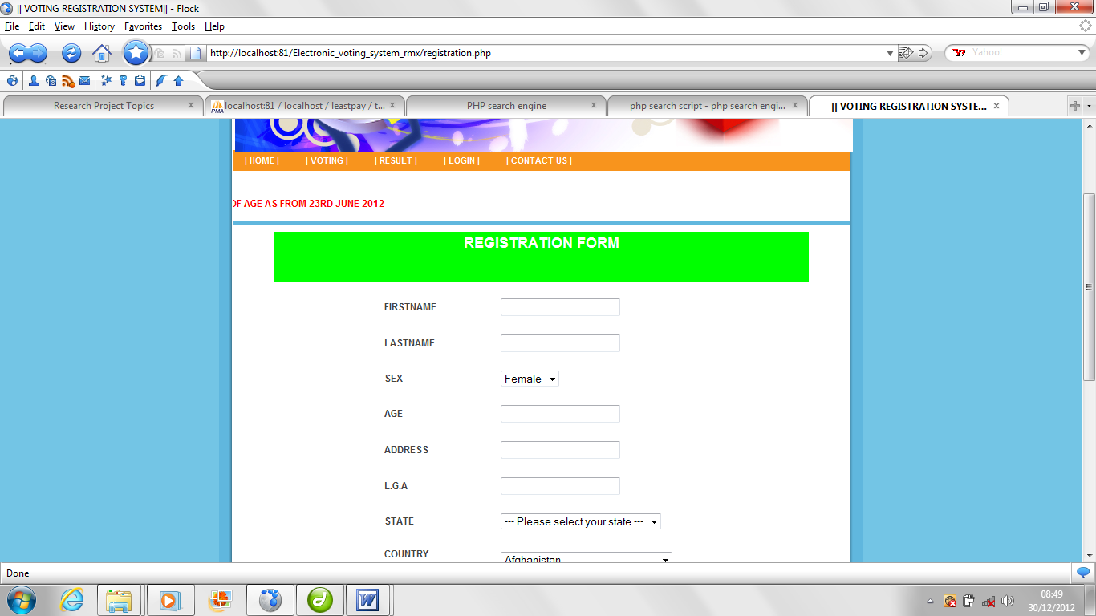

Voting page
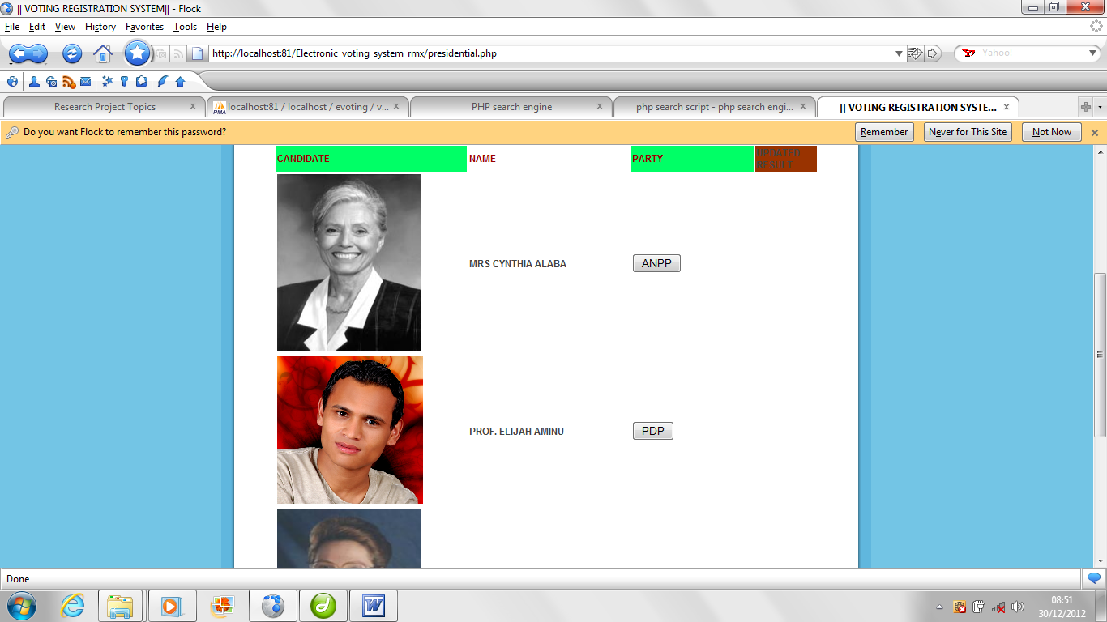

Result page

